Net 1061 Switching, Routing, and Wireless Essentials

Name:

Lab: # 4.5.2 Implement Inter-VLAN Routing

Follow the instructions down below for the lab itself. For this lab, all answers need to be in blue font. For the questions right below, answer in complete sentences. You will also have to copy and paste your running configurations of each device configured to the bottom of this document. Let the instructor know if you have any questions.

Lab Analysis Report

1. Using complete sentences summarize work you completed during the lab.
In this lab, I first cabled all the devices. Then, I did all the basic configurations on the two switches and the router. Then, I assigned the IP addresses to the PCs. Then, I created the VLANs and assigned all the ports to them. Then, I configured the trunk ports and configured router-on-a-stick on the router. Finally, I verified connectivity between the devices.

2. Using complete sentences describe what you learned from the lab. Hint; look at the lab objectives listed at the top of the lab section.
In this lab I learned how to do inter-VLAN routing. I practices my skills of creating VLANs and learned how to configure a router to communicate with the switches and VLANs.

Problems Encountered

1. Using complete sentences describe any problem(s) experienced during lab.
My pings between PC-A and PC-B were failing.

2. Using complete sentences describe how you solved your problem(s).
I solved this problem by assigning the correct default gateway on switch 2.

3. Using complete sentences explain if you needed any assistance with the lab; then list what you learned from that assistance.
I asked Mr. B for assistance to troubleshoot this problem. We went through all the configurations and finally narrowed it down to the default gateway.

Lab - Implement Inter-VLAN Routing

Topology
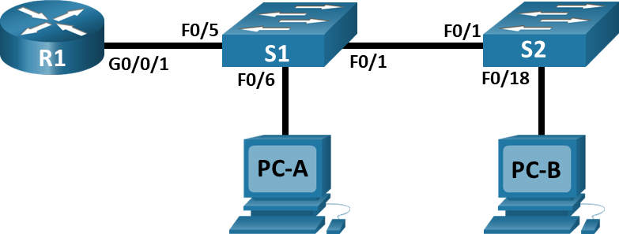

Addressing Table
Device | Interface | IP Address | Subnet Mask | Default Gateway
R1 | G0/0/1.10 | 192.168.10.1 | 255.255.255.0 | N/A
R1 | G0/0/1.20 | 192.168.20.1 | 255.255.255.0 | N/A
R1 | G0/0/1.30 | 192.168.30.1 | 255.255.255.0 | N/A
R1 | G0/0/1.1000 | N/A | N/A | N/A
S1 | VLAN 10 | 192.168.10.11 | 255.255.255.0 | 192.168.10.1
S2 | VLAN 10 | 192.168.10.12 | 255.255.255.0 | 192.168.10.1
PC-A | NIC | 192.168.20.3 | 255.255.255.0 | 192.168.20.1
PC-B | NIC | 192.168.30.3 | 255.255.255.0 | 192.168.30.1

VLAN Table
VLAN | Name | Interface Assigned
10 | Management | S1: VLAN 10  S2: VLAN 10
20 | Sales | S1: F0/6
30 | Operations | S2: F0/18
999 | Parking_Lot | S1: F0/2-4, F0/7-24, G0/1-2  S2: F0/2-17, F0/19-24, G0/1-2
1000 | Native | N/A

Objectives
Part 1: Build the Network and Configure Basic Device Settings
Part 2: Create VLANs and Assign Switch Ports
Part 3: Configure an 802.1Q Trunk between the Switches
Part 4: Configure Inter-VLAN Routing on the Router
Part 5: Verify Inter-VLAN Routing is working

Background / Scenario
Modern switches use virtual local-area networks (VLANs) to improve network performance by separating large Layer 2 broadcast domains into smaller ones. VLANs can also be used as a security measure by separating sensitive data traffic from the rest of the network. In general, VLANs make it easier to design a network to support the goals of an organization. Communication between VLANs requires a device operating at Layer 3 of the OSI model. Adding an inter-VLAN router allows the organization to segregate and separate broadcast domains while simultaneously allowing them to communicate with each other.
VLAN trunks are used to span VLANs across multiple devices. Trunks allow the traffic from multiple VLANs to travel over a single link, while keeping the VLAN identification and segmentation intact. A particular kind of inter-VLAN routing, called “Router-on-a-Stick”, uses a trunk from the router to the switch to enable all VLANs to pass to the router.
In this lab, you will create VLANs on both switches in the topology, assign VLANs to switch access ports, verify that VLANs are working as expected, create VLAN trunks between the two switches and between S1 and R1, and configure Inter-VLAN routing on R1 to allow hosts in different VLANs to communicate, regardless of which subnet the host resides.
Note: The routers used with CCNA hands-on labs are Cisco 4221 with Cisco IOS XE Release 16.9.4 (universalk9 image). The switches used in the labs are Cisco Catalyst 2960s with Cisco IOS Release 15.2(2) (lanbasek9 image). Other routers, switches, and Cisco IOS versions can be used. Depending on the model and Cisco IOS version, the commands available and the output produced might vary from what is shown in the labs. Refer to the Router Interface Summary Table at the end of the lab for the correct interface identifiers.
Note: Ensure that the routers and switches have been erased and have no startup configurations. If you are unsure contact your instructor.

Required Resources
- 1 Router (Cisco 4221 with Cisco IOS XE Release 16.9.4 universal image or comparable)
- 2 Switches (Cisco 2960 with Cisco IOS Release 15.2(2) lanbasek9 image or comparable)
- 2 PCs (Windows with a terminal emulation program, such as Tera Term)
- Console cables to configure the Cisco IOS devices via the console ports
- Ethernet cables as shown in the topology

Instructions

Build the Network and Configure Basic Device Settings
In Part 1, you will set up the network topology and configure basic settings on the PC hosts and switches.

Cable the network as shown in the topology.
Attach the devices as shown in the topology diagram, and cable as necessary.

Configure basic settings for the router.
      - Console into the router and enable privileged EXEC mode.
Open configuration window
      - Enter configuration mode.
      - Assign a device name to the router.
      - Disable DNS lookup to prevent the router from attempting to translate incorrectly entered commands as though they were host names.
      - Assign class as the privileged EXEC encrypted password.
      - Assign cisco as the console password and enable login.
      - Assign cisco as the vty password and enable login.
      - Encrypt the plaintext passwords.
      - Create a banner that warns anyone accessing the device that unauthorized access is prohibited.
      - Save the running configuration to the startup configuration file.
      - Set the clock on the router.

Configure basic settings for each switch.
      - Assign a device name to the switch.
      - Disable DNS lookup to prevent the router from attempting to translate incorrectly entered commands as though they were host names.
      - Assign class as the privileged EXEC encrypted password.
      - Assign cisco as the console password and enable login.
      - Assign cisco as the vty password and enable login.
      - Encrypt the plaintext passwords.
      - Create a banner that warns anyone accessing the device that unauthorized access is prohibited.
      - Set the clock on the switch.
      - Save the running configuration to the startup configuration.
Close configuration window

Configure PC hosts.
Refer to the Addressing Table for PC host address information.

Create VLANs and Assign Switch Ports
In Part 2, you will create VLANs as specified in the table above on both switches. You will then assign the VLANs to the appropriate interface and verify your configuration settings. Complete the following tasks on each switch.

Create VLANs on both switches.
      - Create and name the required VLANs on each switch from the table above.
Open configuration window
      - Configure the management interface and default gateway on each switch using the IP address information in the Addressing Table.
      - Assign all unused ports on the switch to the Parking_Lot VLAN, configure them for static access mode, and administratively deactivate them.
Note: The interface range command is helpful to accomplish this task with as few commands as necessary.

Assign VLANs to the correct switch interfaces.
      - Assign used ports to the appropriate VLAN (specified in the VLAN table above) and configure them for static access mode.
      - Verify that the VLANs are assigned to the correct interfaces.
Close configuration window

Configure an 802.1Q Trunk Between the Switches
In Part 3, you will manually configure interface F0/1 as a trunk.

Manually configure trunk interface F0/1 on switch S1 and S2.
      - Configure static trunking on interface F0/1 for both switches.
Open configuration window
      - Set the native VLAN to 1000 on both switches.
      - Specify that VLANs 10, 20, 30, and 1000 are allowed to cross the trunk.
      - Verify trunking ports, the Native VLAN and allowed VLANs across the trunk.

Manually configure S1’s trunk interface F0/5
      - Configure S1’s interface F0/5 with the same trunk parameters as F0/1. This is the trunk to the router.
      - Save the running configuration to the startup configuration file.
      - Verify trunking.

Question:
What happens if G0/0/1 on R1 is down?
Communication between networks will go down since there is no connection to the Router.
Close configuration window

Configure Inter-VLAN Routing on the Router

Configure the router.
Open configuration window
      - Activate interface G0/0/1 as necessary on the router.
      - Configure sub-interfaces for each VLAN as specified in the IP addressing table. All sub-interfaces use 802.1Q encapsulation. Ensure the sub-interface for the native VLAN does not have an IP address assigned. Include a description for each sub-interface.
      - Verify the sub-interfaces are operational
Close configuration windowVerify Inter-VLAN Routing is Working

Complete the following tests from PC-A. All should be successful.
Note: You may have to disable the PC firewall for pings to work
      - Ping from PC-A to its default gateway.
      - Ping from PC-A to PC-B
      - Ping from PC-A to S2

Complete the following test from PC-B
From the Command Prompt window on PC-B, issue the tracert command to the address of PC-A.

Question:
What intermediate IP addresses are shown in the results?
Tracert was not working.
Paste your configurations here:
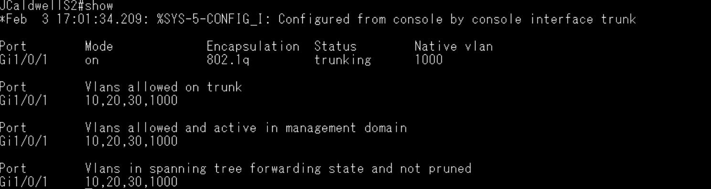
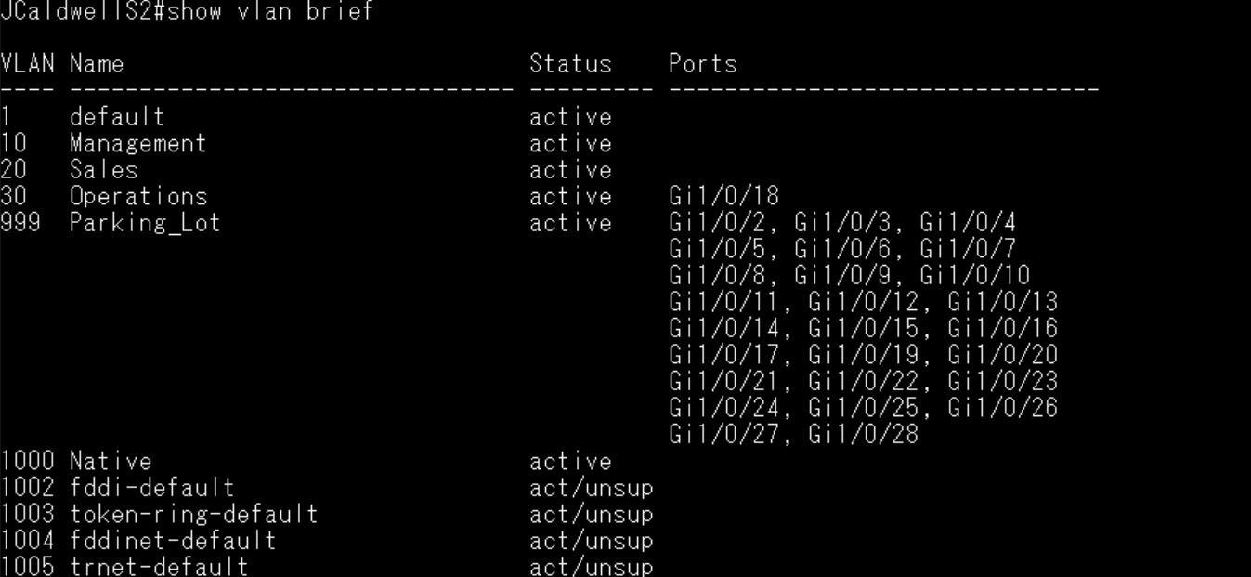
JCaldwellS2#show running-config
Building configuration...

Current configuration : 3691 bytes
!
! Last configuration change at 17:01:34 UTC Tue Feb 3 2026
!
version 15.2
no service pad
service timestamps debug datetime msec
service timestamps log datetime msec
service password-encryption
!
hostname JCaldwellS2
!
boot-start-marker
boot-end-marker
!
enable secret 9 $9$D9n5tN/6ZGhL4p$tZpmXp89.ETlAfD6E9BtrIakaeLRrqNVlzSsGuKsltE
!
no aaa new-model
switch 1 provision c1000-24t-4g-l
system mtu routing 1500
!
!
no ip domain-lookup
!
!
!
!
!
!
!
!
spanning-tree mode rapid-pvst
spanning-tree extend system-id
!
vlan internal allocation policy ascending
!
!
!
!
!
!
interface GigabitEthernet1/0/1
switchport trunk allowed vlan 10,20,30,1000
switchport trunk native vlan 1000
switchport mode trunk
!
interface GigabitEthernet1/0/2
switchport access vlan 999
switchport mode access
shutdown
!
interface GigabitEthernet1/0/3
switchport access vlan 999
switchport mode access
shutdown
!
interface GigabitEthernet1/0/4
switchport access vlan 999
switchport mode access
shutdown
!
interface GigabitEthernet1/0/5
switchport access vlan 999
switchport mode access
shutdown
!
interface GigabitEthernet1/0/6
switchport access vlan 999
switchport mode access
shutdown
!
interface GigabitEthernet1/0/7
switchport access vlan 999
switchport mode access
shutdown
!
interface GigabitEthernet1/0/8
switchport access vlan 999
switchport mode access
shutdown
!
interface GigabitEthernet1/0/9
switchport access vlan 999
switchport mode access
shutdown
!
interface GigabitEthernet1/0/10
switchport access vlan 999
switchport mode access
shutdown
!
interface GigabitEthernet1/0/11
switchport access vlan 999
switchport mode access
shutdown
!
interface GigabitEthernet1/0/12
switchport access vlan 999
switchport mode access
shutdown
!
interface GigabitEthernet1/0/13
switchport access vlan 999
switchport mode access
shutdown
!
interface GigabitEthernet1/0/14
switchport access vlan 999
switchport mode access
shutdown
!
interface GigabitEthernet1/0/15
switchport access vlan 999
switchport mode access
shutdown
!
interface GigabitEthernet1/0/16
switchport access vlan 999
switchport mode access
shutdown
!
interface GigabitEthernet1/0/17
switchport access vlan 999
switchport mode access
shutdown
!
interface GigabitEthernet1/0/18
switchport access vlan 30
switchport mode access
!
interface GigabitEthernet1/0/19
switchport access vlan 999
switchport mode access
shutdown
!
interface GigabitEthernet1/0/20
switchport access vlan 999
switchport mode access
shutdown
!
interface GigabitEthernet1/0/21
switchport access vlan 999
switchport mode access
shutdown
!
interface GigabitEthernet1/0/22
switchport access vlan 999
switchport mode access
shutdown
!
interface GigabitEthernet1/0/23
switchport access vlan 999
switchport mode access
shutdown
!
interface GigabitEthernet1/0/24
switchport access vlan 999
switchport mode access
shutdown
!
interface GigabitEthernet1/0/25
switchport access vlan 999
switchport mode access
shutdown
!
interface GigabitEthernet1/0/26
switchport access vlan 999
switchport mode access
shutdown
!
interface GigabitEthernet1/0/27
switchport access vlan 999
switchport mode access
shutdown
!
interface GigabitEthernet1/0/28
switchport access vlan 999
switchport mode access
shutdown
!
interface Vlan1
no ip address
shutdown
!
interface Vlan10
ip address 192.168.10.12 255.255.255.0
!
ip default-gateway 192.168.10.1
ip http server
ip http secure-server
!
!
!
banner motd ^C Unauthorized access is prohibited ^C
!
line con 0
password 7 030752180500
login
line vty 0 4
password 7 030752180500
login
transport input none
line vty 5 15
password 7 030752180500
login
transport input none
!
End
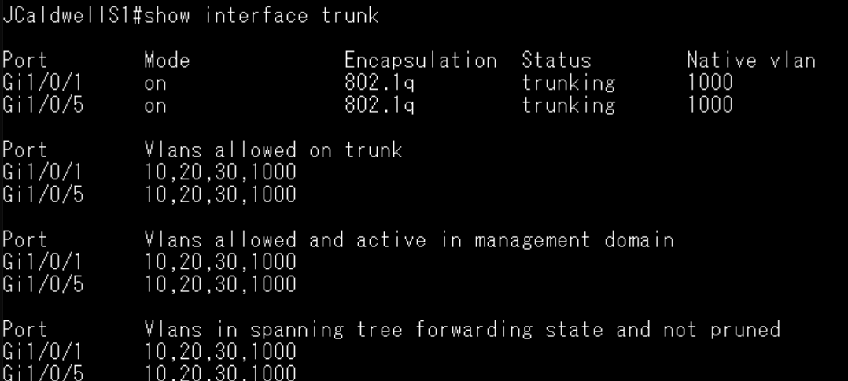
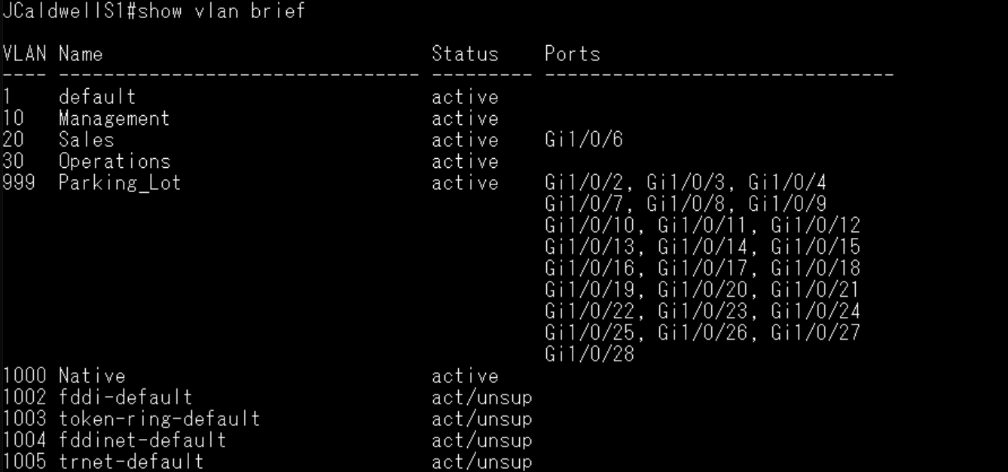

JCaldwellS1#show running-config
Building configuration...

Current configuration : 3641 bytes
!
! Last configuration change at 12:05:49 UTC Tue Feb 3 2026
!
version 15.2
no service pad
service timestamps debug datetime msec
service timestamps log datetime msec
service password-encryption
!
hostname JCaldwellS1
!
boot-start-marker
boot-end-marker
!
enable secret 9 $9$W3FVF0YLY9Mgge$ksNKQp7sgFtTSwWtLGkwxpy7a0RJzgP29qPBU2YNtU6
!
no aaa new-model
switch 1 provision c1000-24t-4g-l
system mtu routing 1500
!
!
no ip domain-lookup
!
!
!
!
!
!
!
!
spanning-tree mode rapid-pvst
spanning-tree extend system-id
!
vlan internal allocation policy ascending
!
!
!
!
!
!
interface GigabitEthernet1/0/1
switchport trunk allowed vlan 10,20,30,1000
switchport trunk native vlan 1000
switchport mode trunk
!
interface GigabitEthernet1/0/2
switchport access vlan 999
switchport mode access
shutdown
!
interface GigabitEthernet1/0/3
switchport access vlan 999
switchport mode access
shutdown
!
interface GigabitEthernet1/0/4
switchport access vlan 999
switchport mode access
shutdown
!
interface GigabitEthernet1/0/5
switchport trunk allowed vlan 10,20,30,1000
switchport trunk native vlan 1000
switchport mode trunk
!
interface GigabitEthernet1/0/6
switchport access vlan 20
switchport mode access
!
interface GigabitEthernet1/0/7
switchport access vlan 999
switchport mode access
shutdown
!
interface GigabitEthernet1/0/8
switchport access vlan 999
switchport mode access
shutdown
!
interface GigabitEthernet1/0/9
switchport access vlan 999
switchport mode access
shutdown
!
interface GigabitEthernet1/0/10
switchport access vlan 999
switchport mode access
shutdown
!
interface GigabitEthernet1/0/11
switchport access vlan 999
switchport mode access
shutdown
!
interface GigabitEthernet1/0/12
switchport access vlan 999
switchport mode access
shutdown
!
interface GigabitEthernet1/0/13
switchport access vlan 999
switchport mode access
shutdown
!
interface GigabitEthernet1/0/14
switchport access vlan 999
switchport mode access
shutdown
!
interface GigabitEthernet1/0/15
switchport access vlan 999
switchport mode access
shutdown
!
interface GigabitEthernet1/0/16
switchport access vlan 999
switchport mode access
shutdown
!
interface GigabitEthernet1/0/17
switchport access vlan 999
switchport mode access
shutdown
!
interface GigabitEthernet1/0/18
switchport access vlan 999
switchport mode access
shutdown
!
interface GigabitEthernet1/0/19
switchport access vlan 999
switchport mode access
shutdown
!
interface GigabitEthernet1/0/20
switchport access vlan 999
switchport mode access
shutdown
!
interface GigabitEthernet1/0/21
switchport access vlan 999
switchport mode access
shutdown
!
interface GigabitEthernet1/0/22
switchport access vlan 999
switchport mode access
shutdown
!
interface GigabitEthernet1/0/23
switchport access vlan 999
switchport mode access
shutdown
!
interface GigabitEthernet1/0/24
switchport access vlan 999
switchport mode access
shutdown
!
interface GigabitEthernet1/0/25
switchport access vlan 999
switchport mode access
shutdown
!
interface GigabitEthernet1/0/26
switchport access vlan 999
switchport mode access
shutdown
!
interface GigabitEthernet1/0/27
switchport access vlan 999
switchport mode access
shutdown
!
interface GigabitEthernet1/0/28
switchport access vlan 999
switchport mode access
shutdown
!
interface Vlan1
no ip address
shutdown
!
ip http server
ip http secure-server
!
!
!
banner motd ^C Unauthroized access is prohibited ^C
!
line con 0
password 7 13061E010803
login
line vty 0 4
password 7 13061E010803
login
transport input none
line vty 5 15
password 7 13061E010803
login
transport input none
!
End
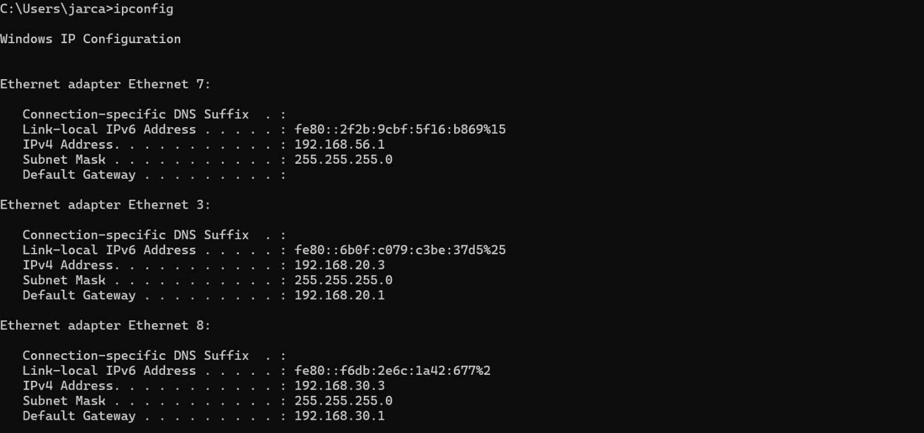
JCaldwellR1#show running-config
Building configuration...

Current configuration : 6608 bytes
!
! Last configuration change at 17:08:46 UTC Tue Feb 3 2026
!
version 17.3
service timestamps debug datetime msec
service timestamps log datetime msec
service password-encryption
! Call-home is enabled by Smart-Licensing.
service call-home
platform qfp utilization monitor load 80
platform punt-keepalive disable-kernel-core
!
hostname JCaldwellR1
!
boot-start-marker
boot-end-marker
!
!
vrf definition Mgmt-intf
!
address-family ipv4
exit-address-family
!
address-family ipv6
exit-address-family
!
enable secret 9 $9$Dx73ZmuJt6NXrE$OREY8YbfcBEZO5L1dzxnqhRDyOeUqFMFUCbIJU8M/xw
!
no aaa new-model
!
!
!
!
!
!
!
no ip domain lookup
!
!
!
login on-success log
!
!
!
!
!
!
!
subscriber templating
multilink bundle-name authenticated
no device-tracking logging theft
!
!
!
crypto pki trustpoint TP-self-signed-2037616329
enrollment selfsigned
subject-name cn=IOS-Self-Signed-Certificate-2037616329
revocation-check none
rsakeypair TP-self-signed-2037616329
!
crypto pki trustpoint SLA-TrustPoint
enrollment pkcs12
revocation-check crl
!
!
crypto pki certificate chain TP-self-signed-2037616329
certificate self-signed 01
30820330 30820218 A0030201 02020101 300D0609 2A864886 F70D0101 05050030
31312F30 2D060355 04031326 494F532D 53656C66 2D536967 6E65642D 43657274
69666963 6174652D 32303337 36313633 3239301E 170D3236 30323033 31363234
32385A17 0D333630 32303331 36323432 385A3031 312F302D 06035504 03132649
4F532D53 656C662D 5369676E 65642D43 65727469 66696361 74652D32 30333736
31363332 39308201 22300D06 092A8648 86F70D01 01010500 0382010F 00308201
0A028201 0100CB96 A078952F 67926A12 98F38176 CA95ADC0 0097E86D 9A561D1B
80D87B22 BF40C955 6B2D0F95 9C38D9D5 E7579599 A5CC6DEF 8FCB67B8 1E971682
2812DA02 29F9C061 81160401 50F7032E 5205B283 88BCA5B6 9B606317 7093004B
38879554 CB45E2ED A4B0912A 84B2507F 6526D646 ED2885E7 CE346C21 6C944BE6
8C9D0094 1F683CA8 31DE16EB 86329AAD 8F642317 E148EB8B A28D2973 27B3C921
4BDD77C3 9C492933 510D704D E1C59B49 CEF63E34 FFAEF599 B650074A 4971AB6E
E89F199C C07800F3 74273045 0F13A0DD 76A3AFFD 99D07EE7 012C90F3 75757A88
EE68BB18 610F7319 A4373653 E75F832E 536B2C69 39D121BF 9C1EC6B8 A0540A16
A7206DBC 77070203 010001A3 53305130 0F060355 1D130101 FF040530 030101FF
301F0603 551D2304 18301680 14FD80BB 1699F0DB 84CBFA68 9A66895E 8B8D1FBD
72301D06 03551D0E 04160414 FD80BB16 99F0DB84 CBFA689A 66895E8B 8D1FBD72
300D0609 2A864886 F70D0101 05050003 82010100 994B354D 877B6B47 0BB2AA2B
EB3A3412 CBB0C186 FA6F4D66 1F67535A E027483F D6CED23D BCE5DAD0 B586E0BD
87D78084 7B9775C5 ED46CA33 B4D80A35 0C43F807 39419733 07F89D18 7F5B50E6
D8418380 B6D7DE71 10F5F47D 39A1AF89 DB4ABBFC DA87747D EDB4A0D0 6D155758
D54D2366 F253EA6A C65312F8 FDE6F4B0 6A4621B7 45090137 C5B2E27E BDF8FCF9
16B5151E 329E0222 92B29F50 1F0A0426 D4F7E49E 09C544F3 8E372B60 C760BEED
51FE5C4E 0EC3F550 036EEA81 9F831DA6 D663C287 29970777 B058D0C7 0CE1A9B1
296A35F5 46D522D3 A9B264B1 96F9B820 BF2ECCF6 CCFE33E2 E5AC9950 09A1EFCD
6F185661 1AD1F9D0 E343CF80 67E6B587 4B21B3D2
quit
crypto pki certificate chain SLA-TrustPoint
certificate ca 01
30820321 30820209 A0030201 02020101 300D0609 2A864886 F70D0101 0B050030
32310E30 0C060355 040A1305 43697363 6F312030 1E060355 04031317 43697363
6F204C69 63656E73 696E6720 526F6F74 20434130 1E170D31 33303533 30313934
3834375A 170D3338 30353330 31393438 34375A30 32310E30 0C060355 040A1305
43697363 6F312030 1E060355 04031317 43697363 6F204C69 63656E73 696E6720
526F6F74 20434130 82012230 0D06092A 864886F7 0D010101 05000382 010F0030
82010A02 82010100 A6BCBD96 131E05F7 145EA72C 2CD686E6 17222EA1 F1EFF64D
CBB4C798 212AA147 C655D8D7 9471380D 8711441E 1AAF071A 9CAE6388 8A38E520
1C394D78 462EF239 C659F715 B98C0A59 5BBB5CBD 0CFEBEA3 700A8BF7 D8F256EE
4AA4E80D DB6FD1C9 60B1FD18 FFC69C96 6FA68957 A2617DE7 104FDC5F EA2956AC
7390A3EB 2B5436AD C847A2C5 DAB553EB 69A9A535 58E9F3E3 C0BD23CF 58BD7188
68E69491 20F320E7 948E71D7 AE3BCC84 F10684C7 4BC8E00F 539BA42B 42C68BB7
C7479096 B4CB2D62 EA2F505D C7B062A4 6811D95B E8250FC4 5D5D5FB8 8F27D191
C55F0D76 61F9A4CD 3D992327 A8BB03BD 4E6D7069 7CBADF8B DF5F4368 95135E44
DFC7C6CF 04DD7FD1 02030100 01A34230 40300E06 03551D0F 0101FF04 04030201
06300F06 03551D13 0101FF04 05300301 01FF301D 0603551D 0E041604 1449DC85
4B3D31E5 1B3E6A17 606AF333 3D3B4C73 E8300D06 092A8648 86F70D01 010B0500
03820101 00507F24 D3932A66 86025D9F E838AE5C 6D4DF6B0 49631C78 240DA905
604EDCDE FF4FED2B 77FC460E CD636FDB DD44681E 3A5673AB 9093D3B1 6C9E3D8B
D98987BF E40CBD9E 1AECA0C2 2189BB5C 8FA85686 CD98B646 5575B146 8DFC66A8
467A3DF4 4D565700 6ADF0F0D CF835015 3C04FF7C 21E878AC 11BA9CD2 55A9232C
7CA7B7E6 C1AF74F6 152E99B7 B1FCF9BB E973DE7F 5BDDEB86 C71E3B49 1765308B
5FB0DA06 B92AFE7F 494E8A9E 07B85737 F3A58BE1 1A48A229 C37C1E69 39F08678
80DDCD16 D6BACECA EEBC7CF9 8428787B 35202CDC 60E4616A B623CDBD 230E3AFB
418616A9 4093E049 4D10AB75 27E86F73 932E35B5 8862FDAE 0275156F 719BB2F0
D697DF7F 28
quit
!
!
license udi pid ISR4321/K9 sn FLM254904JP
memory free low-watermark processor 69075
!
diagnostic bootup level minimal
!
spanning-tree extend system-id
!
!
redundancy
mode none
!
!
!
!
!
!
!
!
interface GigabitEthernet0/0/0
no ip address
shutdown
negotiation auto
!
interface GigabitEthernet0/0/1
no ip address
negotiation auto
!
interface GigabitEthernet0/0/1.10
encapsulation dot1Q 10
ip address 192.168.10.1 255.255.255.0
!
interface GigabitEthernet0/0/1.20
encapsulation dot1Q 20
ip address 192.168.20.1 255.255.255.0
!
interface GigabitEthernet0/0/1.30
encapsulation dot1Q 30
ip address 192.168.30.1 255.255.255.0
!
interface GigabitEthernet0/0/1.1000
encapsulation dot1Q 1000 native
!
interface GigabitEthernet0
vrf forwarding Mgmt-intf
no ip address
shutdown
negotiation auto
!
ip http server
ip http authentication local
ip http secure-server
ip forward-protocol nd
ip tftp source-interface GigabitEthernet0
!
!
!
!
!
!
control-plane
!
banner motd ^C Unauthorized access is prohibited ^C
!
line con 0
password 7 110A1016141D
login
stopbits 1
line aux 0
stopbits 1
line vty 0 4
password 7 02050D480809
login
transport input ssh
line vty 5 15
password 7 02050D480809
login
transport input ssh
!
call-home
! If contact email address in call-home is configured as sch-smart-licensing@cisco.com
! the email address configured in Cisco Smart License Portal will be used as contact email address to send SCH notifications.
contact-email-addr sch-smart-licensing@cisco.com
profile "CiscoTAC-1"
active
destination transport-method http
!
!
!
!
!
!
end

